

Behaviour Policy

Approved by the Board of Directors: January 2024
Review Date: January 2027

Contents:

Aims and Values | 1
Behaviour Curriculum | 1
Additional support for Behaviours | 1
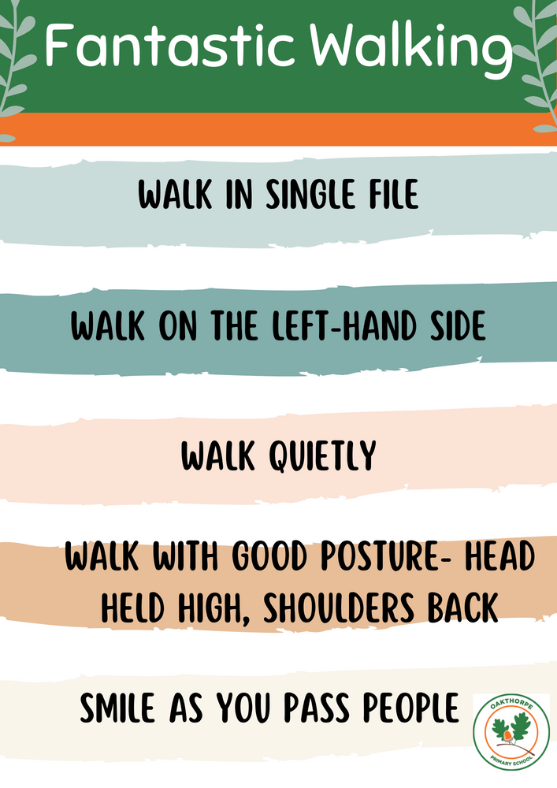  Whole School rules | 2
Frisby School rules | 2
Praise and Rewards | 4
Corridor Expectations | 4
Break and Lunch time play | 4
Dining Hall Expectations | 4
Assembly and Worship Expectations | 4
Visitor and Visitors Expectations | 4
Roles and Responsibilities | 5
Sanctions | 7
Reasonable Force and Positive Handling | 8
Confiscation | 9
Zero tolerance approach to sexual harassment and sexual violence | 9
Monitoring Behaviour | 10
Logging Behaviour on Arbor | 10
Appendix 1 | 12
Appendix 2 | 13

Aim and values
It is our aim through this behaviour policy that every school member feels valued and respected, and that each person is treated fairly. Our school is a caring community which values high expectations and positivity and is held together through strong relationships and communication skills. We wish to establish a culture which is based on clear teaching and modelling of the correct behaviours; managed in a way which is warm and caring. We believe that children should learn how to be responsible for their actions, property and regard for others and will therefore become intrinsically motivated displaying helpfulness, co-operation and problem-solving skills. This will diminish the need for extrinsic motivation through coercion, sanctions external rewards. We will work collaboratively with parents to create a positive ethos where all children are given all the tools they need, in order to make positive behaviour choices.

"Good relationships are built out of structures and high expectations. The teacher-student relationship is important, but it is built on trust – and trust is built on mutually predictable behaviour. And that requires sincerely executed norms and routines. But we do not expect students to only behave when they have a strong relationship with all staff. The expectation is that students should behave well because it is the right thing to do.” Tom Bennett
Sources
Our behaviour policy has been developed after extensive research using these sources:
- Creating a culture: How school leaders can optimise behaviour – Tom Bennett (2017)
- Teach like a champion – Doug Lemov (2015)
- Running the room – Tom Bennett
- Improving behaviour in schools- The Education Endowment Foundation (2019)
- Exemplary Leadership professional development (speakers including David Didau, Tom Bennett, Annie Carter, Barry Smith, Andrew Percival and Sonia Thompson).
- DFE Behaviour in Schools – September 2022
- Positive environments where children can flourish – Ofsted 2021
- Use of reasonable force in schools – DFE July 2013

Behaviour curriculum
At Frisby, we have designed a behaviour curriculum which ensures that children are explicitly taught how to behave, this is underpinned by the values of the Rise multi academy trust. These are Respect, Compassion, Truthfulness, Inclusivity and Collaboration. The behaviour curriculum sets out the strategies and techniques used to improve behaviour in our schools so that all pupils are able to learn in a safe, calm, orderly and predictable environment.
Additional support for behaviours
As a school, we recognise our duty under the Equality Act 2010 to prevent pupils with a protected characteristic from being disadvantaged. We value that all children have a variety of needs within their learning and learning behaviours and that some pupils will need additional support and different approaches. Therefore, when needed we work with a range of outside agencies, medical practitioners and educational psychologists to ensure that reasonable adjustments and personalised plans can be developed so that children can be successful. Many children who have additional needs will have an individualised behaviour plan that is followed by all staff and shared with the child’s parents/carers. Rise also have a senior behaviour mentor who works across the trust to support schools with behaviour.
Whole school rules
We believe that our school rules will help us to provide a safe, friendly, encouraging and positive school environment where each person is valued and has the optimum access to their learning.
These rules will be consistently applied throughout the school by all members of staff, including lunchtime supervisors and sports coaches. Due to the teaching, modelling and coaching process, all children will be explicitly taught these skills. All children have a clear understanding of what is expected of them around school and therefore understand the consequences of their actions.
Frisby School rules
Routines and expectations
Mastering Me- every school year will begin with a Mastering Me week where children will be explicitly taught and have all behaviours modelled to them. Children will practice the different behaviours in different opportunities within school and at different times of the day. Staff will consistently remind, reinforce and re-model behaviours during this time in a warm and caring manner.
Stepping up and shaping up- after each half term, there will be a key behaviour focus for the whole school which will be highlighted in worship and assemblies with all adults then modelling in class and around school.
Classroom expectations
We aim to provide a rich and balanced curriculum through high quality teaching and learning experiences. Through good teacher subject knowledge, small steps planning and scaffolding to support the needs of all learners, there should be minimal opportunity for disruptive behaviour. All members of staff are entrusted with ensuring high expectations are consistently maintained to manage inappropriate behaviour swiftly and effectively, following the scripts and strategies outlined within the behaviour policy. A combination of verbal praise, postcards home, feedback (including modelling) and sanctions are used to encourage good behaviour. Any other reward systems are only to be used with the agreement of school leaders and will often be in place temporarily.
All children are explicitly taught to …

Follow instructions from an adult FIRST TIME, EVERYTIME
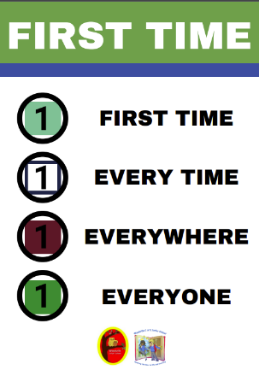
First time – pupils know they should follow an instruction straight away and that it should not need to be repeated.
- Every time – pupils know that adults in school will only ask them reasonable requests so they should always follow them.
- Everywhere – pupils know that the same expectations apply in class, in corridors, in halls, playgrounds, schools, in church, outside in the community and on school trips.
- Everyone – pupils know that they should follow instructions from every adult in school no matter what their job title or position.

Listen well using STAR listening.
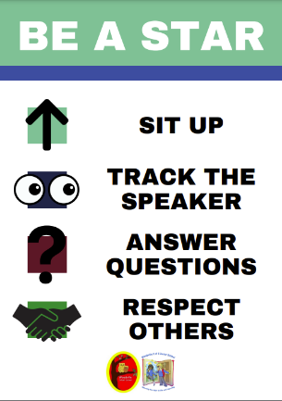
- Sit up straight in their chair, hands together on the table, two feet are flat on the floor.
- Track the speaker – pupil know they need to look at the person who is speaking including their peers.
- Answer questions – pupils know that everyone is expected to answer questions to the best of their ability.
- Respect others – pupils know they must never interrupt others.

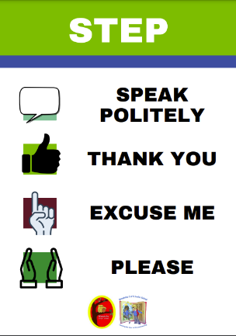
Show excellent STEP manners.

- Speak politely – pupils know the importance of manners and that they and the adults are expected to use them at all times. This includes thank you, excuse me, please.
- Thank you.
- Excuse me
- Please

Speak well using SHAPE your answer.
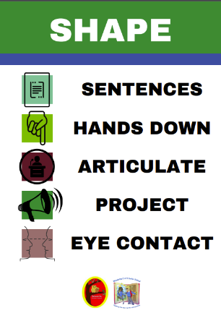
- Sentences – pupils know they must answer in full sentences when appropriate.
- Hands down – pupils know that anyone could be called on to answer questions.
- Articulate – pupils know they must pronounce words clearly.
- Project – pupils know they must speak with a voice that is loud enough for everyone to hear.
- Eye contact – pupils know that it is polite to look at the person they are speaking to (we recognise that this is a challenge for some pupils and would always respect and support the needs of individuals when modelling eye contact)

Walk calmly around the school using FANTASTIC WALKING
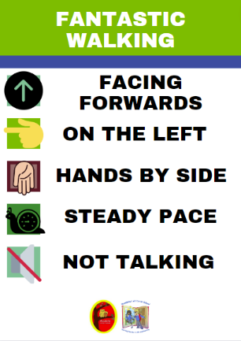
- Facing forward – pupils know that they need to look where they are going to make sure everyone is safe.
- On the left – pupils know that they need to walk down the left-hand side of the corridor.
- Hands by side – pupils know that they should have their hands down by their side or behind their backs when walking around school.
- Steady pace – pupils know that they should walk at a steady pace and never run in school so that everyone is safe.
- Not talking – pupils know that corridors need to be calm and quiet so learning in classroom is not disrupted.

Praise and rewards
It is important that children’s successes are celebrated and affirmed through positive praise. Children will receive positive recognition from staff when they are doing the right thing, their behaviour will be described and the reason why it is positive explained. Praise postcards will be awarded and sent home for excellent behaviour that is sustained over time. Any other reward systems are only to be used with the agreement of school leaders and will often be in place temporarily. Children understanding and meeting the high expectations of behaviour set by staff should be the norm.
Corridor expectations
It is expected that corridors will be calm to ensure that distractions are kept to the absolute minimum. Children are expected to move around school calmly using Fantastic Walking. Adults are expected to consistently monitor, praise and model Fantastic Walking.
Break and lunch time play
We recognise that break/lunch time and fresh air are a fundamental aspect in creating a positive, safe learning environment. By providing structured playground activities, we encourage children to have experiences which benefit their social, emotional and physical wellbeing. We endeavour to offer opportunities for children to develop social skills, practice sports skills, enjoy free time and be creative.
Staff at break and lunch will ensure that they work according to the agreed zoning plan provided.
Children will have appropriate activities available (e.g., board games, cards, puzzles, colouring) during occasions of wet play.
Dinner Hall expectations
Lunchtime is an important part of the day for children at Frisby to benefit from the social conventions of sharing a meal with others. We encourage children to use STEP, good table manners, eat well and to appropriately socialise during the lunch hour. Detailed expectations for dinner hall behaviour can be found in our behaviour curriculum.
Assembly and Worship expectations
Our assemblies and worship are an important part of bringing the whole school together to share key messages which support our school values. We expect children and adults to use FANTASTIC WALKING to enter and exit and STAR listening throughout. Detailed expectations for assembly and collective worship behaviour can be found in our behaviour curriculum.
Visits and visitor expectations
When school welcomes visitors in, children and adults will greet visitors warmly by saying good morning/good afternoon. When children are out of school, all members of our school community act as ambassadors and representatives of our values and the highest standards of behaviour and conduct are expected. Detailed expectations for behaviour on school visits can be found in our behaviour curriculum.
Roles and responsibilities
It is the overall responsibility of the Headteacher to ensure that high standards of behaviour and conduct are maintained on a daily basis.
However, it is imperative that all members of the Frisby community play their part in the teaching, learning and maintaining of high standards of behaviour at all times.
The Senior Leadership Team will;
- Ensure that the high expectations of behaviour and conduct are consistently promoted throughout the school.
- Ensure the health, safety and welfare of all staff and children.
- Lead by example in the consistent implementation of the behaviour policy by being a positive role model.
- Consistently use the shared language from STEP, SHAPE, STAR, FIRST and FW when talking to children about their behaviour
- Ensure all teaching staff, support staff, lunchtime supervisors and sports coaches receive high quality training, CPD and resources to support the teaching and management of expected standards of behaviour.
- Regularly monitor that the behaviour policy and behaviour curriculum is being implemented with fidelity across the school, with all staff members
- Share information in regard to the effectiveness of the behaviour policy and behaviour curriculum with the governors, LA and the trust
- Promote the use of warmth alongside high expectations when praising and modelling behaviour strategies, including during assemblies and worship, messages home to parents and positive feedback.
- Support staff in dealing with dangerous pupil behaviour, including coaching, de-briefing after significant events and wellbeing checks.
- Support staff in strategies to be used with persistent disruptive or difficult behaviours, including the development and use of personalised behaviour plans.
- Ensure appropriate and proportionate use of sanctions are implemented in line with this policy.
- Investigate behaviours and trends logged on Arbor, updating any actions with outcomes in a timely manner.
- Support staff to work closely with parents/carers when a child/children show challenging behaviours.
- Ensure a zoning plan is in place for break and lunch.
All teaching and support staff will;
- Ensure that the high expectations of behaviour and conduct are consistently promoted throughout the school.
- Explicitly teach the whole school rules and behaviour curriculum to children using the resources provided.
- Make sure that they are always present in the classroom to supervise children.
- Be positive role models- use of appropriate, warm tone of voice, language and volume to model good behaviour to children.
- Ensure that they stay in control in conflict moments to enable them to be proactive instead of reactive.
- Prepare equipment and materials before the lesson begins.
- Plan and deliver/support effective lessons, taking into account children’s starting points and behavioural needs.
- Be proactive and limit the opportunities for students to lose focus or misbehave.
- Use positive praise and reinforcement to encourage good behaviour.
- Celebrate children’s successes through positive praise, individual behaviour plans, sending pupils for praise from other staff, certificates and awards and celebratory postcards sent through the post.
- When required by SLT complete the Behaviour Log consistently to ensure all stages have been followed and all behaviours are being monitored (Appendix 1)
- Work consistently with lunchtime supervisors to ensure good behaviour is promoted over lunchtime.
- Use and apply the Frisby Behaviour Stages in conjunction with the 30 second Behaviour Script to ensure consistency of response and language used (Appendix 2).
- Work with SLT to create personalised behaviour plans where necessary.
- Work with SLT for support in developing strategies for children showing challenging behaviours.
- Build strong links with parents, communicating successes and positive feedback as well as concerning behaviours in a timely manner- be sensitive to parents need for feedback to be given in
- Record stage 3 and above behaviours on Arbor in line with the Frisby Behaviour Stages using the Incident, Action, Outcome model.
- Consistently use the shared language from STEP, SHAPE, STAR, FIRST and FW when talking to children about their behaviour
Lunchtime supervisors will;
- Ensure that the high expectations of behaviour and conduct are consistently promoted during lunchtime.
- Be positive role models.
- Be proactive in using a range of strategies to limit confrontation, de-escalate situations and minimise misbehaviour.
- Greet children as they enter the dining hall.
- Use children’s names when addressing them.
- Smile and use positive feedback often throughout lunch time to identify good behaviour.
- Encourage children to join in with different activities on the playground.
- Ensure children use Fantastic Walking around school.
- Communicate successes of behaviour and any concerns with class teacher in a timely manner
- Follow Frisby Behaviour Stages to ensure that disruptive and difficult behaviours are dealt with effectively (ensuring that the chain of adults to intervene is followed correctly and matches the behaviour type)
- Report any stage 3 and above behaviour on Arbor using the Incident, Action, Outcome model.
- Use the shared language from STEP, SHAPE, STAR, FIRST, FW when talking to children about their behaviour.
- Work according to agreed playground zoning plan
Children will;
- Ensure that the high expectations of behaviour and conduct are consistently promoted around school.
- Always follow the school rules and routines
- Accept responsibility for their actions and the impact this has on others.
- Accept feedback from adults, including sanctions for their actions, modelling of correct behaviour and use this to make better choices in the future.
Parents will;
- Support the high expectations of behaviour and conduct at XXX Schools, the behaviour policy and behaviour curriculum including sanctions.
- Work closely with school to communicate concerns and to share successes for their child.
- Inform the school of any events or changes which may impact on their child’s behaviour.
- Attend meetings to discuss behaviour and conduct for their child when requested.
- Discuss the expectations of behaviour and conduct with their child, emphasising their support.
- Recognise that high quality teaching and learning is not able to take place unless good behaviour is in place.
- Be assured that all staff will respond to behaviour concerns appropriately following the schools’ policies and procedures.
Governing body/Trust will;
- Carry out their statutory duty relating to exclusions and disciplinary issues.
- Review the frequency of significant behaviour incidents.
- Give support to school in implementing policy documents, monitoring its implementation and effectiveness.
Sanctions
Sanctions are given to ensure children understand the consequences of their actions and to safeguard other children and adults in school and to enable effective teaching and learning to take place. In order to be effective, they do not have to be severe but do need to be consistent and certain.
All staff will use the behaviour stages to ensure appropriate and logical consequences are given.
We recognise that incidents can be complex and will always be investigated to ensure that the consequence to an action is based around the level of risk to others, the intention and the lead up to the event. Consequences will not always be instant as time must be allowed for investigations to take place.
Suspension and permanent exclusions
The school will use suspension and permanent exclusions in response to serious incidents or persistent dangerous behaviour. The decision to make any exclusions will be made by the Headteacher after consultation with the Director of Education. Schools will follow the Rise Exclusions policy which is in line with the regulations set out by the DFE in September 2023 and the relevant Local Authority information.
Bullying
Bullying is defined as the repetitive harming of one person or group by another person or group. It is deliberately hurtful, repeated and over a period of time. (STOP- Several Times On Purpose)
There are different types of bullying;
- Emotional: for example, leaving you out or hiding your things, this can be done through a third person who may spread rumours about you or get someone else to give nasty messages.
- Physical: for example, punching or kicking you.
- Verbal: for example, calling you names or being sarcastic.
- Cyber: for example, sending you nasty texts or emails.
Bullying can take different forms;
- Racial, religious, or cultural bullying where the motivation is based on someone’s skin colour, culture, nationality or faith.
- Sexual: can relate to the target’s gender or body, this can have a sexual and/or sexist element.
- Homophobic and Biphobic: relates to a person’s sexual orientation. It is based on prejudice or negatives, beliefs or views about lesbian, gay or bi people. Individual or groups can be targeted because of their actual or perceived sexuality.
- Transphobic: relates to gender identity, it is based on prejudice or negative attitudes, views or beliefs about trans people. Transphobic bullying affects people who are trans but can also affect those questioning their gender identity as well as people who are not trans but do not conform to gender stereotypes.
- SEN and Disability: where an individual or group are targeted because of a special education need or disability that includes learning difficulties, sensory impairments and mental health conditions.
- Appearance or health conditions: where an individual or group are targeted because of their physical appearance or a health condition, for example a disfigurement, a traumatic injury or severe skin condition.
- Home circumstances: where the motivation for bullying is based on the person’s living arrangements, for example, young carers, children in care of geographic locality, i.e. where they live.
Please see our anti-bullying policy for more information.
Reasonable force and positive handling
All members of school staff have a legal power to use reasonable force to prevent pupils from hurting themselves or others, from damaging property, from committing an offence or using disorder.
The use of positive handling as a means of reasonable force is not taken lightly.
Any use of positive handling methods must be:
- Carried out by trained members of staff*.
- Always as a last resort
- Be applied using the minimum amount of force, for the minimum amount of time.
- Be applied in a way which ensures the safety and dignity of all involved.
- Be recorded on Arbor
- (and bound book as appropriate) and reported to parents.
- A full de-brief of the event will be held by SLT with any members of staff involved.
- A full de-brief of the event will be held with the child involved.
- Training updates will be held termly for members of staff with current positive handling training.
*In an emergency situation all staff have the power to use reasonable force to prevent pupils from hurting themselves or others.
Confiscation
Any prohibited items found in pupil’s possession will be confiscated. These items will not be returned to pupils. We will also confiscate any item which is harmful or detrimental to school discipline, these items will be returned to pupils after discussion with senior leaders and parents, if appropriate. Screening and searching pupils is conducted in line with the DfE’s latest guidance on searching, screening and confiscation. Prohibited items include;
- Knives or weapons
- Alcohol
- Illegal drugs
- Stolen items
- Cigarettes, cigarette papers
- Fireworks
- Pornographic images
- Any article a staff member reasonably suspects has been, or is likely to be, used to commit an offence or to cause personal injury to, or damage to the property of, any person (including pupils).
Zero-tolerance approach to sexual harassment and sexual violence
The school will ensure that all incidents of sexual harassment and/or violence are met with a suitable response, never ignored and are investigated thoroughly. Pupils are encouraged to report anything that makes them uncomfortable, no matter how ‘small’ they feel it might be.
The school’s response will be;
- Proportionate
- Considered
- Supportive
- Decided on a case-by-case base
Sanctions for sexual harassment and violence may include;
- Phone call to parents
- Remove to SLT
- Internal exclusion
- Suspension
- Permanent exclusion
The school has procedures in place to respond to any allegations or concerns about a child’s safety or wellbeing. These include clear processes for;
- Responding to a report by investigating thoroughly
- Carrying out risk assessment, were appropriate, to help determine whether to manage the incident internally, refer to early help, refer to children’s social care, report to the police. Please refer to our child protection and safeguarding policy for more information.
Monitoring behaviour
The Headteacher will consistently monitor and support behaviour through high visibility around school. All staff are expected to record incidents on behaviour trackers when requested and to log behaviour concerns (Stage 3 and above) on Arbor and so the Headteacher will monitor these, investigating further when necessary.
The Headteacher will collate information from behaviour trackers when they are in use to monitor frequency of different levels of behaviour.
Analysis of behaviour monitoring will be shared with the governing body through the Headteacher’s Report.
Logging Behaviour incidents on Arbor
All behaviour (Stage 3 and above) will be logged on Arbor, this does not need to be done immediately but should be done by the end of that day and should be recorded by the person who dealt with the incident. Logs should follow the Incident, Action, Outcome structure and use the language of the behaviour policy.
Example behaviours at each stage serve to act as a guide. Response will often be very much context driven. For example, not keeping hands and feet to themselves can range in context, severity etc, throwing objects could be in a defiant manner or throwing something carelessly to another pupil. These behaviour stages would not apply to a pupil with an individual behaviour plan.
Frisby Behaviour Stages
Stages |  | Response
Level 1  - Out of seat/calling out/ interrupting teacher during whole class/ loud noises/ interrupting other children  - Inappropriate language (not aimed at others)  - Not listening  - Not keeping hands and feet to themselves | 1st Verbal warning  Logged on behaviour tracker if in use. | Low key response  Positive Choices  Praise those making the correct choices.  Rule reminder/ quiet reminder  Support children to make the right choice.    Verbal reminder “At Frisby we…”
Level 2 Continued  - Out of seat/calling out/ interrupting teacher during whole class/ loud noises/ interrupting other children  - Inappropriate language (not aimed at others)  - Not listening  - Not keeping hands and feet to themselves | 2nd Verbal Warning  Logged on behaviour tracker if in use | Positive Choices  Praise those making the correct choices.  Rule reminder/ quiet reminder  Support children to make the right choice.    Verbal reminder “At Frisby we…”  If third expectation is broken, go to level 3 (Short Logical Consequence with explanation why)
Level 3  - Inappropriate language aimed at others.  - Beginning to challenge authority at a minor level.  - Treating classroom without respect | Incident logged on Arbor by person dealing with behaviour. | Rule reminder  “At Frisby we…,  By doing/making the choice to…  you are….  This means that… (short logical consequence)  Praise those making correct choices.  Support children to make the right choice.  Consequences could be:  Losing time from playtime/lunchtime  Work sent home.  Work re-done.  Anything logical  Class teacher to discuss with parent at the end of the day.
Level 4  - Continued disruption to class and others despite Level 1 or Level 2 response.  - Obstructive behaviour in refusing to participate/refuse to work. | Incident logged on Arbor by person dealing with behaviour. |   Rule reminder  “At Frisby we…,  by doing/making the choice to…  you are….  This means that… (longer logical consequence)  Praise those making correct choices.  Support children to make the right choice.  Consequences could be:  Losing time from playtime/lunchtime  Work sent home.  Work re-done.  Anything logical  Call home to parent by class teacher.
Level 5  - Serious and deliberate behaviour  - Rudeness to adults  - Leaving room without permission  - Continued refusal to complete set tasks after having level 2 consequence.  - Upsetting and name calling to other pupils  - Highly disruptive behaviour  - Throwing objects across the room  - Bullying | Incident logged on Arbor by person dealing with behaviour. | Rule reminder  “At Frisby we…,  By doing/making the choice to…  you are….  This means that… (longer logical consequence)  Consequences could include:  Full play/lunch lost.  Work sent home.  Internal exclusion for next lesson including play/lunch.  Praise those making correct choices.  Phone call home made by class teacher
Level 6  - Persistent level 5 behaviour  - Persistent offensive/ abusive language  - Throwing objects to hurt  - Deliberately break/destroy class equipment.  - Deliberately physically hurting children or adults  - Deliberately damaging property  - Racist/Religious/ homophobic behaviour  - Theft  - Possession of prohibited items  - Sexual violence  - Sexual harassment | Incident logged on Arbor by person dealing with behaviour.  Immediate SLT involvement | Consequences:  Internal Exclusion  Suspension  Permanent Exclusion  School exclusion procedure and policy to be followed.  An individual behaviour plan is written in conjunction with SLT. School office to invite parents to meet with class teacher and senior leader to discuss and agree behaviour plan before return to class.

Appendix 1 - 30 Second Scripts – Frisby Behaviour Responses
It’s my job to keep you/everyone safe and to keep you/everyone learning …so you can’t go back into the classroom at the moment until you are calm, so we’ll need to stop and wait until everyone is listening, so you will need to go back down the corridor and show me fantastic walking.

At Frisby we … do fantastic walking, sit up, are respectful, follow instructions the first time they are asked.

I need you to …. show fantastic walking, pick up your pencil and start work, hang your coat up and come to your seat, take down your hood.

I noticed you are… having trouble getting started/struggling to get going/wandering around the classroom talking.

It was the rule about… lining up/staying on task/staying quiet that you broke.

You have now chosen to… move to the back/catch up with your work at lunchtime/lose X minutes of your break time.

Do you remember last week when you… arrived on time every day/made me smile/helped to hand out the books/lined up like a soldier

That is exactly the behaviour I need to see today…

Thank you for listening. Then give the child some ‘take up’ time and walk away.

Fantastic walking Every single time you see a child doing it”.

Appendix 2
 | Out of seat/calling out/ interrupting teacher during whole class/ loud noises/ interrupting other children |  | Inappropriate language (not aimed at children) | Not listening | Not keeping hands and feet to themselves | Continued - Out of seat/calling out/ interrupting teacher during whole class/ loud noises/ interrupting other children. | Continued - Inappropriate language (not aimed at others) | Continued - Not listening. | Continued - Not keeping hands and feet to themselves | Inappropriate language aimed at others. | Beginning to challenge authority/ minor level. | Treating classroom without respect | Continued disruption to class and other despite Level 1 or Level 2 | Obstructive behaviour in refusing to participate/refuse to work. | Serious and deliberate  rudeness to adults | Leaving room without permission | Continues refusal to complete set tasks after having level 2 consequence. | Upsetting and name calling to other pupils | Highly disruptive behaviour | Throwing objects across the room | Persistent offensive/ abusive language | Throwing objects to hurt | Break/destroying class equipment. | Physically hurting others | Damaging property | Racist/Religious/ homophobic incident
 | Stage 1 |  |  |  |  | Stage 2 |  |  | Stage 3  (Log on Arbor) |  | Stage 4  (Log on Arbor) |  |  |  |  |  | Stage 5  (Log on Arbor) |  |  |  |  |  | Stage 6  (Log on Arbor)  SLT involvement
Name

